AIM
MD.070 Application Extension Technical Design
Life Fitness
Insert Customers Shopify to Oracle EBS Integration
Author: Ajay Murugesan
Creation Date: Sep 15,2025
Last Updated: Sep 15,2025
Document Ref: V1.0
Version: DRAFT 1A

Title, Subject, Last Updated Date, Reference Number, and Version are marked by a Word Bookmark so that they can be easily reproduced in the header and footer of documents. When you change any of these values, be careful not to accidentally delete the bookmark. You can make bookmarks visible by selecting Tools->Options…View and checking the Bookmarks option in the Show region.
Approvals:
Nandini Ram
Zach Heuer
To add additional approval lines, press [Tab] from the last cell in the table above.
You can delete any elements of this cover page that you do not need for your document. For example, Copy Number is only required if this is a controlled document and you need to track each copy that you distribute.

Copyright Notice
The contents of this document are proprietary to HIG. and shall not be disclosed, disseminated, copied, or used except for purposes expressly authorized in writing by HIG.

Document Control

Change Record
4
Date | Author | Version | Change Reference
 | Lali
Sep 15,2025 | Ajay Murugesan | Draft 1A | No Previous Document

Reviewers

Name | Position

Note To Holders:
If you receive an electronic copy of this document and print it out, please write your name on the equivalent of the cover page, for document control purposes.
If you receive a hard copy of this document, please write your name on the front cover, for document control purposes.
Contents
Document Control ii
Technical Overview 1
Approach 1
Module List 1
Table and View Usage 1
Incompatibility 1
Performance Considerations 1
Other Considerations 2
Integration details 3
Architecture 3
Block Diagram 3
Oracle Integration Cloud 4
Oracle EBS Dbaas Cloud Adapter 4
REST Adapter Shopify 4
OIC Environment Details 5
Integration Basic Details 5
Field Mappings 6
Lookups 7
Integration Issues 10
Changes Required 10
Shared Components 10
Alert conditions 10
Incompatibilities 10
Performance Issues 10
Database Design 11
Desired Table Changes 11
New/Updated Seed Data 11
Descriptive Flexfields 11
Value Sets 11
Grants/Synonyms 11
Archiving 11
Implementation Notes 12
Design Summary 12
Testing Summary 12
Open and Closed Issues for this Deliverable 13
Open Issues 13
Closed Issues 13

To update the table of contents, put the cursor anywhere in the table and press [F9]. To change the number of levels displayed, select the menu option Insert->Index and Tables, make sure the Table of Contents tab is active, and change the Number of Levels to a new value.

Technical Overview
This document defines the technical aspect of understanding the Customer Integration (OIC) requirement. This integration creates customer in EBS from the source system Shopify and updates the Customer in EBS back to Shopify.

Approach
- When a Customer/Location is created or updated in the Shopify will run the EBS concurrent program which triggers OIC Customer integration and sends the details to EBS to create the Customer/Location and Updates it back to Shopify.
- The REST connection from Shopify is used to get the Customer details.
If the Functional Design included a Technical Overview section, duplicate that information here and add additional details.

Module List

Concurrent Programs
EBS concurrent program

Database Triggers
Add other components above as required
EBS staging table to post the new/updated Customer details

The diagram above is just an example—Double click on it to edit it as an embedded object. Select it and choose Edit->VISIO Object->Open to open it in the full Visio application.
You can also use Oracle Developer to draw your diagram and define most of the information in this section.

Table and View Usage
Cust/Std tables
Table Name | Select | Insert | Update | Delete | Base Table
 | X
XXLF_SHOPIFY_EBS_ACCOUNTS_STG | N/A | YES | N/A | N/A
XXLF_SHOPIFY_EBS_ACNTS_IMP_STG | YES | N/A | N/A | N/A

Incompatibility
N/A

Performance Considerations
The performance is good as we have wrapper and child integration where we can process multiple sales order at a time from child integration

Other Considerations

Restart Strategy
N/A

Crash Recovery
N/A

Integration details

Architecture
As part of this integration, the systems below are involved.
REST (Shopify) – Where the Customer/Customer Location data will be fetches in the shopify.
Oracle EBS DB – Where Customer details from the EBS staging table post by using Execution Id.

Block Diagram
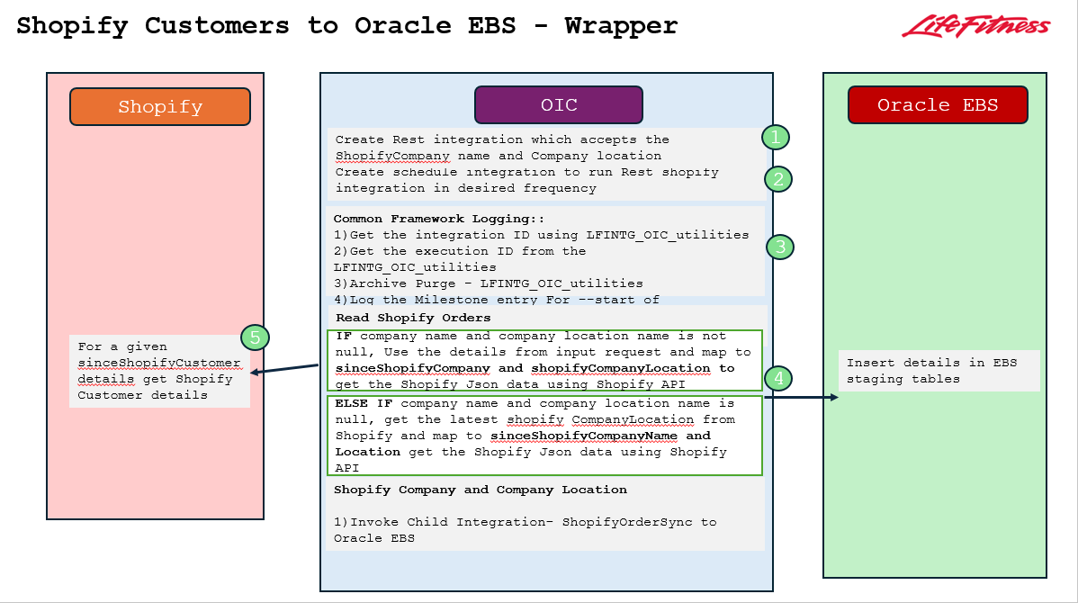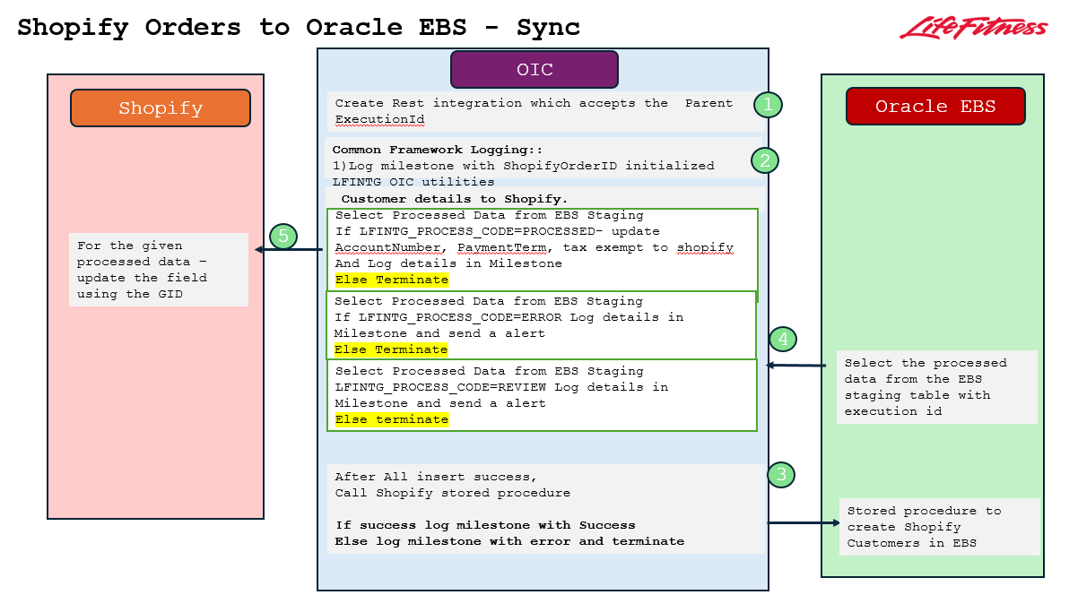

Oracle Integration Cloud

Oracle EBS Dbaas Cloud Adapter

Attribute | Value – Dev | Value - Prod
Type | Oracle DBaaS
Name | OracleEBS_Shared_Conn
Identifier | ORACLEEBS_SHARED_CONN
Role | Trigger and invoke
Security Policy | Oracle Wallet
Username
Password

REST Adapter Shopify

Attribute | Value – Dev | Value - Prod
Type | REST
Name | LF_Shopify_B2B_Rest
Identifier | LF_Shopify_B2B_Rest
Role | Invoke
Connection URL | https://lf-b2b-dev.myshopify.com/admin/api
Security policy | Basic Authentication
Username | <value of username>
Password | <value of username>

REST Adapter Shopify
Attribute | Value – Dev | Value - Prod
Type | REST
Name | LF_Shopify_B2B_Rest
Identifier | LF_Shopify_B2B_Rest
Role | Trigger
Security policy | Basic Authentication
Username | <value of username>
Password | <value of username>

OIC Environment Details
Attribute | Attribute value - Dev | Attribute value - Prod
URL | https://lfnoicdev01n-lifefitness-ia.integration.us-ashburn-1.ocp.oraclecloud.com/ic/api/integration/v2/flows/rest/project/LF_SHOPIFY_ORACLEEBS/LF_ORACL_SHOPI_CUSTO_CREAT_WRAPP/1.0/B2B/UserCUSTOMERS/trigger
Username | <value of user>
Password | <value of password>
Version | Gen 3

Integration Basic Details
Attribute | Attribute value - Dev | Attribute value - Prod
Name | LF_OracleEBS_Shopify_Customer_Create_Wrapper
Identifier | LF_ORACL_SHOPI_CUSTO_CREAT_WRAPP
Version | 01.00.0001
Package | -
Description | -

Attribute | Attribute value - Dev | Attribute value - Prod
Name | LF_Shopify_OracleEBS_ShopifyCustomer_Creation_Sync
Identifier | LF_SHOPI_ORACL_SHOPI_CREAT_SYNC
Version | 01.00.0004
Package | -
Description | -

Field Mappings
Map to InsertOrderHeaderRow
Table name: - XXLF_SHOPIFY_EBS_ACCOUNTS_STG

Shopify Column | EBS Column
Companies/Name | CompanyName
Customers/displayName | name
Customers/Email | Email
Customers/FirstName | FirstName
Customer/LastName | LastName
Customers/phone | Phone
Location/Id | gId
oic_execution_id | lfintgExecutionId
billing_address/address1 | BillingStreet
billing_address/city | BillingCity
billing_address/country | BillingCountry
billing_address/Province | BillingState
billing_address/zip | BillingPostalCode
billing_address/Country_code | BillingCounty
shipping_address/address1 | ShippingStreet
shipping _address/city | ShippingCity
shipping _address/country | ShippingCountry
shipping _address/Province | ShippingState
shipping _address/zip | ShippingPostalCode
shipping _address/Country_code | ShippingCounty
shipping _address/city | ShippingCity
shipping _address/country | ShippingCountry
shipping _address/Province | ShippingState
MetaFields/Scifit_Dealer | scifitDealerFlag

Map to UpdateShopify-AccountNumber
Table Name:- XXLF_SHOPIFY_EBS_ACNTS_IMP_STG
EBS Column | Shopify Column
G_Id | companyLocationId
ACCOUNT_NUMBER | externalId
Map to UpdateShopify-PaymentTerms
Table Name:- XXLF_SHOPIFY_EBS_ACNTS_IMP_STG
EBS column | Shopify Column
G_Id | companyLocationId
PAYMENT_TERM_ID | paymentTermsTemplateId

Map to UpdateShopify-PaymentTerms
Table Name:- XXLF_SHOPIFY_EBS_ACNTS_IMP_STG
EBS column | Shopify Column
TAX_EXEMPT_NUMBER | company_tax_exempt/Value
G_Id | Metafield/ownerId

Map to CallOracleConcurrentJob
Package Name:- XXLF_LFINTG_OIC_UTIL_PKG
Procedure Name:- SUBMIT_CONC_REQUEST_EMAIL
Shopify Column | EBS Column
Oic Execution Id | lfintgExecutionId
 | P_USER – SubmitConcRequestUser (function)
 | RESPONSIBILITY – SubmitConcRequestResponsibility (function)
 | APPLICATION – SubmitConcRequestApplication (function)
 | PROGRAM_NAME – SubmitConcRequestProgramName (function)
 | P_EMAIL – SubmitConcRequestEmail (function)
 | ARGUMENT1 - SubmitConcRequestArgument1 (function)

Lookups
The below lookup is built for changes to be made in Shopify enpoints.
Lookup attributes | Development Value | Production Value
Name | LF_Shopify_EndPoints
Property | Value
Shopify_API_Version | 2025-04
The below lookup is built for Concurrent program configuration.

Lookup attributes | Development Value | Production Value
Name | LF_Shopify_Configuration_Properties
Property | Value
Shopify_API_Version | 2025-04
SubmitConcRequestUser | PTHIRIVEEDI
SubmitConcRequestResponsibility | SYSADMIN FOR I/S
SubmitConcRequestApplication | Custom Accounts Receivable
SubmitConcRequestProgramName | LF shopify Customer Trigger Prgram
SubmitConcRequestArgument1 | Cett Test
SubmitConcRequestEmail | Cett Test
OracleInProcessCode | INSERTING

The below lookup is built for sending notifications if the integration fails apart from logic

Lookup attributes | Development Value | Production Value
Name | LF_Shopify_Configuration_Properties
Property | Value
From_email | dev_oic_integration@noreply.com
Environment | IDEV
To_Email | lalitha.padala@ennvee.net,  shubham.gupta@ennvee.net,  vindhya.kodiganti@lifefitness.com
EmailNotificationFlag | Y
Cc_Email | lalitha.padala@ennvee.net,  shubham.gupta@ennvee.net,  vindhya.kodiganti@lifefitness.com

Integration Issues

Changes Required

Within Product
-

Other Products
No changes required.

Shared Components
The Oracle Application product short names listed below are examples only. Update the shared component information to reflect the requirements of your customization.

Project – LF_Shopify_OracleEBS

Alert conditions
None.

Incompatibilities
None.

Performance Issues
None.

Database Design
N/A

Desired Table Changes
None

New/Updated Seed Data
Rows added to <App Prefix>_LOOKUPS:
Lookup Type | Code | Meaning

Descriptive Flexfields
N/A

Value Sets
N/A

Grants/Synonyms
N/A

Archiving
No need to archive.

Add to or modify this list as appropriate. Provide additional details where necessary to facilitate the creation of the installation routines.

Implementation Notes
Complete this section after completing the <Subject> customization. Update the design to reflect any changes made in the course of development and describe how the customization was implemented below.
This document describes exactly how <Subject> was developed and implemented at <Company Long Name>.

Design Summary

Testing Summary
Indicate the specific menu options added to access new forms.

Open and Closed Issues for this Deliverable
Add open issues that you identify while writing or reviewing this document to the open issues section. As you resolve issues, move them to the closed issues section and keep the issue ID the same. Include an explanation of the resolution.
When this deliverable is complete, any open issues should be transferred to the project- or process-level Risk and Issue Log (PJM.CR.040) and managed using a project level Risk and Issue Form (PJM.CR.040). In addition, the open items should remain in the open issues section of this deliverable, but flagged in the resolution column as being transferred.

Open Issues

ID | Issue | Resolution | Responsibility | Target Date | Impact Date

Closed Issues

ID | Issue | Resolution | Responsibility | Target Date | Impact Date

